[Course](https://lms.codinginvaders.com/courses/course-v1:CodingInvaders+DATEST+1/course/) [Power BI Module 2](https://lms.codinginvaders.com/courses/course-v1:CodingInvaders+DATEST+1/course/#block-v1:CodingInvaders+DATEST+1+type@chapter+block@36557622a84d4f12b2bee8ab42b193b4) [Introduction](https://lms.codinginvaders.com/courses/course-v1:CodingInvaders+DATEST+1/course/#block-v1:CodingInvaders+DATEST+1+type@sequential+block@2188668a8f9e4ac8ab5557099b19e9d8) Structure

## **Structure**

Bookmark this page

**Part 1 – Types of Visuals in Power BI**

* Different types of Visuals in Power BI
  + Table
  + KPI’s
  + Key Influencers Chart
  + Cards – Single Card, Multi Card
  + Matrix
  + Maps – Basic Maps
  + Legend and Tooltips
  + Filter Types – Report level, Page level, Visual level

**Part 2 – Managing Relationships between Tables in Power BI**

* What are Relationships in Power BI
  + 1. Use of Relationships in Power BI
* Relationship using Auto Detect
* Create a Relationship Manually

**Part 3 – Addition of New columns using Power Query**

* What is Power Query in Power BI?
* Addition of Columns using Power Query
  + 1. Demo to add Columns using Power Query
* Addition of different Columns
  + 1. Custom Columns, Index Columns, Conditional Columns
* Formatting Text and Number Fields

**Part 4 – Transforming Columns in Query Editor**

* Header Row Transformation
* Identifying and Changing Data Type of Attribute
* Pivot / Unpivot Columns
* Join / Merge Columns

[Course](https://lms.codinginvaders.com/courses/course-v1:CodingInvaders+DATEST+1/course/) [Power BI Module 2](https://lms.codinginvaders.com/courses/course-v1:CodingInvaders+DATEST+1/course/#block-v1:CodingInvaders+DATEST+1+type@chapter+block@36557622a84d4f12b2bee8ab42b193b4) [Introduction](https://lms.codinginvaders.com/courses/course-v1:CodingInvaders+DATEST+1/course/#block-v1:CodingInvaders+DATEST+1+type@sequential+block@2188668a8f9e4ac8ab5557099b19e9d8) Dataset Explanation

## **Dataset Explanation**

Bookmark this page

**Demo Dataset**

An Office Supplies Dataset which has details of items supplied to the office and its corresponding billing details.

Download the dataset here: [**Office Supplies Data**](https://lms.codinginvaders.com/assets/courseware/v1/8a254e6f2c439512cd9de5b3c8170650/asset-v1:CodingInvaders+DATEST+1+type@asset+block/OfficeSupplies.xlsx)

***Table Description***

| **Sl. No** | **Column Name** | **Description** |
| --- | --- | --- |
| 1 | Order Date | Date on which Order is placed from Office |
| 2 | Region | Region is direction of location where office is situated |
| 3 | Rep | Rep is representative name from office for corresponding Order |
| 4 | Item | Item is the Item name which was ordered by Office |
| 5 | Units | Units is the quantity of items ordered by office |
| 6 | Unit Price | Unit Price is the billed amount per each unit of corresponding item ordered |
| 7 | Target | Target Unit Price is expected target price of supplies to office |

**Demo dataset Sample**

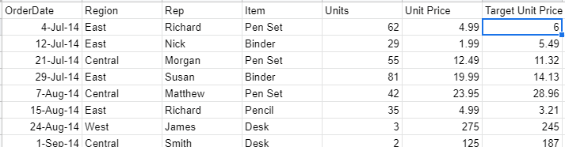



#### **Guided Dataset**

Bank Customers Data contains Customer details including balance and bank balance targets region-wise.

Download the dataset here: [**Bank Customers Data**](https://lms.codinginvaders.com/assets/courseware/v1/0ede07717d9bbd9d566f1c10749fe54f/asset-v1:CodingInvaders+DATEST+1+type@asset+block/Bank_Customers_Data.xlsx)

***Table Description***

| **Sl.No** | **Column Name** | **Description** |
| --- | --- | --- |
| 1 | Customer ID | Customer ID is a unique ID for each individual customer |
| 2 | Name | First Name of Customer |
| 3 | Surname | Last Name of Customer |
| 4 | Gender | Gender of Customer (Male or Female) |
| 5 | Age | Age of customer |
| 6 | Region | Region is location of Bank where customer is holding account |
| 7 | Direction | Direction is where region is located on Map |
| 8 | Job Classification | Job classification is assigned based on their workplace and type of work involved |
| 9 | Date Joined | Date of opening Bank Account |
| 10 | Balance | Balance is total deposit amount in customer account |
| 11 | Target Balance | Target Balance is total expected deposit from bank management in customer account |

[Course](https://lms.codinginvaders.com/courses/course-v1:CodingInvaders+DATEST+1/course/) [Power BI Module 2](https://lms.codinginvaders.com/courses/course-v1:CodingInvaders+DATEST+1/course/#block-v1:CodingInvaders+DATEST+1+type@chapter+block@36557622a84d4f12b2bee8ab42b193b4) [Part 1 - Types of Visuals in Power BI](https://lms.codinginvaders.com/courses/course-v1:CodingInvaders+DATEST+1/course/#block-v1:CodingInvaders+DATEST+1+type@sequential+block@a8cd2c0694cf4c4fb786ed0e3fb3a88d) Different types of Visuals in Power BI

## **Different types of Visuals in Power BI**

Bookmark this page

There are different Visuals to explain Data in Power BI ranging from Graphs, Charts to Maps to make it easy to understand for any user. Below are some important Visuals listed below,

### **Table**

A table is a grid that contains related data in a logical series of rows and columns. It may also contain headers and a row for totals. Tables work well with quantitative comparisons where you're looking at many values for a single category.

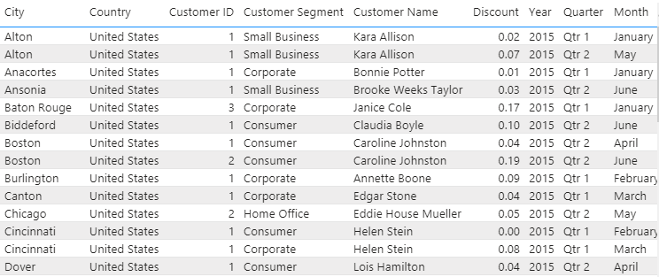

**Demo Exercise**

**Question:** Office has been supplied with items requested based on orders. Manager wants to know the Total units of all items supplied to the office. Create a Table to obtain the result and enter the total number of units in the answer box.

**Instruction:** Create a Table by adding Item and Sum of Units in Values which gives the Total number of items supplied.

**Answer:** 2121

**Solution:** From the given data, we can see that there are a total 2121 units supplied to the office.

***Demo Exercise: Table***

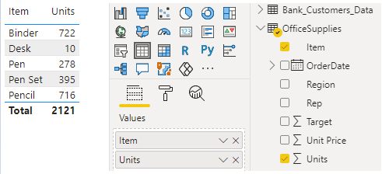

### Question 1

1/1 point (graded)

A Bank has customers data with their balance details. The Bank Manager would like to know the total balance of all customer accounts. Create a table to obtain the result and enter the total balance of all customers in the answer box.

correct

3379713.37

Loading

1. Hint (1 of 1): Create a table and add Customer ID, Name and Balance to Values by selecting the corresponding checkboxes.

Next Hint

Review

HintShow answer

Submit

Some problems have options such as save, reset, hints, or show answer. These options follow the Submit button.

### **KPI (Key Performance Indicator)**

A performance indicator or key performance indicator is a type of performance measurement. It is a visual that communicates the amount of progress made towards a measurable goal.



**Demo Exercise**

**Question:** From Office Supplies, Management wants to know the total Total number of units Supplied for the year of 2015. Create a KPI to obtain the result and enter Total number of units in the answer box.

**Instruction:** Create a KPI and add Sum of Units to Indicator, Order Date(for the Year 2015) to Trend Axis and Target to Target Goals.

**Answer:** 1165

**Solution:** From the given data, we can see that there are 1165 Units supplied to the office.

***Demo Exercise: KPI***

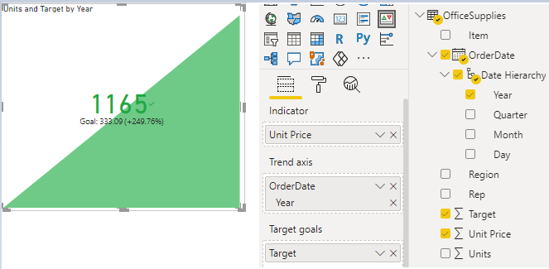

### Question 1

1/1 point (graded)

From Bank Customers Data, Regional Manager would like to know Total Balance for the Year 2015 Month Wise. Create a KPI to obtain the result and enter the total Balance amount in the answer box.

correct

763251.59

Loading

1. Hint (1 of 1): Create a KPI and add Balance to the Indicator section, Date (Month) to Trend Axis and Target Balance to Target Goals.

Next Hint

Review

HintShow answer

Submit

Some problems have options such as save, reset, hints, or show answer. These options follow the Submit button.

**Key Influencer Chart**

The key influencers’ visual helps to understand the factors that drive KPIs. Once a metric that we want to analyze is selected, the key influencers visualization helps investigate what matters the most in driving that metric. This visualization makes use of machine learning under the covers to analyze data and provides interesting insights about the key drivers impacting the metric that we want to analyze. The main advantage of this visual is, it lets us analyze a metric from various perspectives, without the need of keeping any influencer(s) constant.

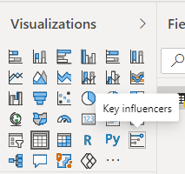

**Demo Exercise**

**Question:** From Office Supplies, Management wants to find by how much amount the average of Target is increasing? Create a Key influencer chart to find the amount and enter the result in the answer box.

**Instruction:** Create a Key Influencer Chart and add Target to Analyze section and add Unit Price, Item to Explain by section.

**Answer:** 34.16

**Solution:** From the given Key Influencer chart, we can observe that Target Price is directly proportional to Unit Price of item.

***Demo Exercise: Key Influencers***

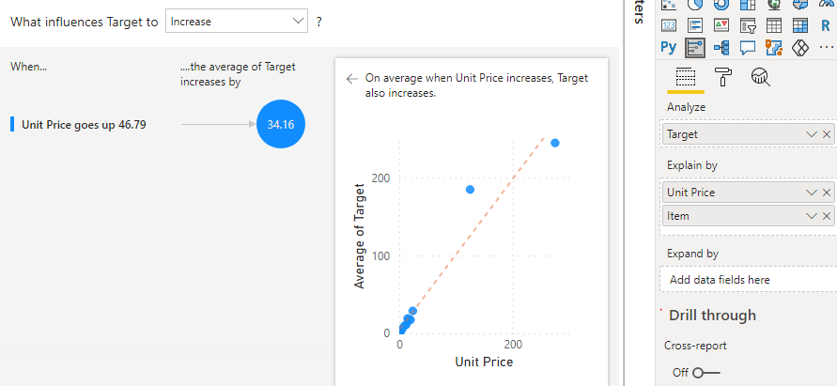

### Question 1

0/1 point (graded)

From Bank Customers Data, Bank Manager wants to know how much the Target balance is going down to decrease the average of Balance? Create a Key influencer chart to obtain the result and enter it in the answer box.

incorrect

28814.71

Loading

1. Hint (1 of 1): Create a Key influencer Chart and add Balance to Analyze section and add Target Balance and Job classification to “Explain By” section.

Next Hint

Review

Hint

Submit

Some problems have options such as save, reset, hints, or show answer. These options follow the Submit button.

### **Cards**

Card Visual in Power BI is helpful to display aggregated information on Dashboards. These cards can be used to present final Metrics on Dashboard.

**Single Card Visual**

Single Card is used to present Single row Aggregations on a Card.

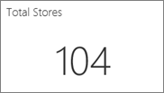

**Multi Card Visual**

Multi Card is used to present Multiple row aggregations in a single card.

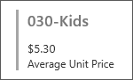

**Demo Exercise**

**Question:** From Office Supplies, Procurement Executive wants to know the total number of Binder units supplied to office? Create a Multi row card to obtain the result and enter the total number of Binder units in the answer box.

**Instruction:** Create a Multi row Card Visual and add Items, Units to Fields section.

**Answer:** 722

**Solution:** From Multi row card Visual, all the items are displayed by total number of units.

***Demo Exercise : Multi Row Card***

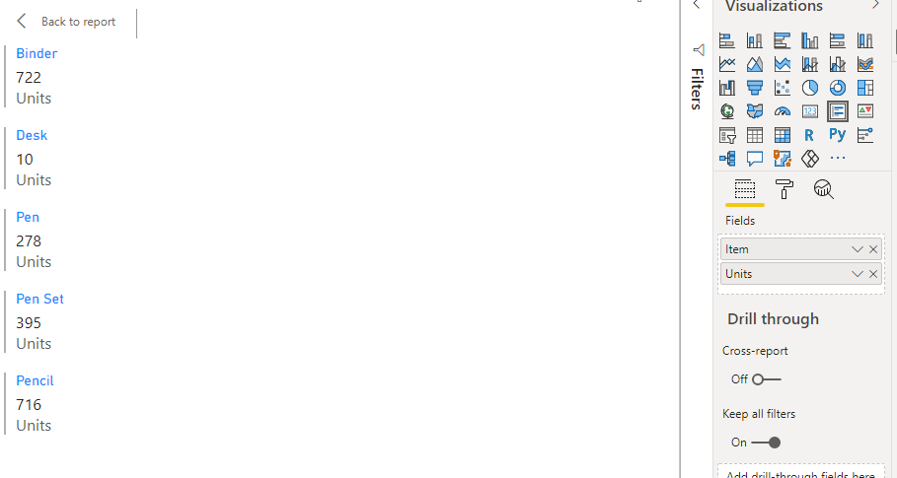

### Question 1

1/1 point (graded)

From Bank Customers Data, the CEO would like to know what is the Target Balance of the England Region? Create a Multi row card to obtain the result and enter Target Balance of England Region in the answer box.

correct

1980058.89

Loading

1. Hint (1 of 1): Create a Multi Row card Visual and add Target Balance, Region to Fields section.

Next Hint

Review

HintShow answer

Submit

Some problems have options such as save, reset, hints, or show answer. These options follow the Submit button.

### Question 2

1/1 point (graded)

From Bank Customers Data, the Business team would like to know the Balance of Female Account Holders in the Northern Ireland Region. Create a Multi Row card Visual to answer this question.

correct

162973.85

Loading

1. Hint (1 of 1): Create a Multi Row card Visual and add Gender, Region and Balance to Fields section.

Next Hint

Review

HintShow answer

Submit

Some problems have options such as save, reset, hints, or show answer. These options follow the Submit button.

### **Matrix**

The matrix visual is like a table. A table supports two dimensions and the data is flat, meaning duplicate values are displayed and not aggregated. A matrix makes it easier to display data meaningfully across multiple dimensions -- it supports a stepped layout. The matrix automatically aggregates the data and enables drill down.

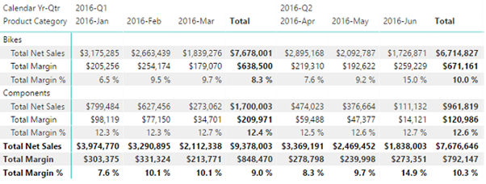

**Demo Exercise**

**Question:** From Office Supplies, Manager would like to know total supplies of Pen for the Month of October. Create a Matrix to obtain the result and enter total supplies of Pens in the answer box.

**Instruction:** Create a Matrix and add Order Date (select Month in Hierarchy) to Rows, Item to Columns and Units to Values.

**Answer:** 64

**Solution:** From Matrix, we could observe total supplies of Pen for the month of October.

***Demo Exercise: Matrix***

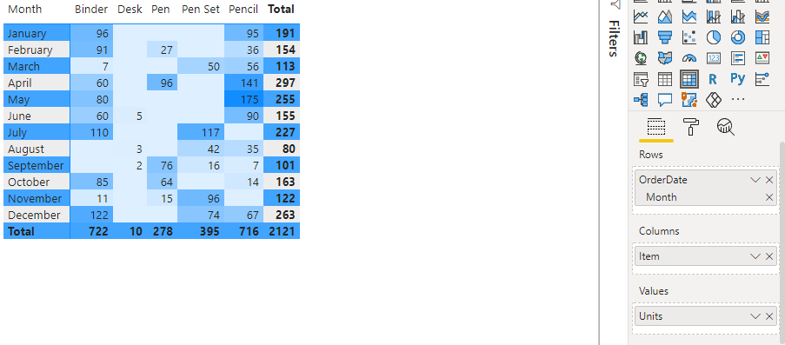

### Question 1

1/1 point (graded)

From Bank Customers Data, the Business Development Team would like to know the total Balance for the Month of February for Wales Region. Create a Matrix to obtain the result and enter total balance for the month of february for wales region in the answer box.

correct

78139.02

Loading

1. Hint (1 of 1): Create a Matrix and add Month to Rows, Region to Columns and Balance to Values.

Next Hint

Review

HintShow answer

Submit

Some problems have options such as save, reset, hints, or show answer. These options follow the Submit button.

### Question 2

1/1 point (graded)

From Bank Customers Data, the Manager would like to know the total Target Balance and Balance of Blue collar Job classification for the Month of March. Create a Matrix to obtain the result and enter the total Balance of Blue collar customers in the answer box.

correct

84064.89

Loading

1. Hint (1 of 1): Create a Matrix and add Month to Rows, Job Classification to Columns and Target Balance & Balance to Values with Background Colour.

Next Hint

Review

HintShow answer

Submit

Some problems have options such as save, reset, hints, or show answer. These options follow the Submit button.

### **Maps**

Power BI has the feasibility to integrate with Bing Maps to provide data in the form of a Map Visual specified below. This kind of Visuals are helpful to represent location wise data.

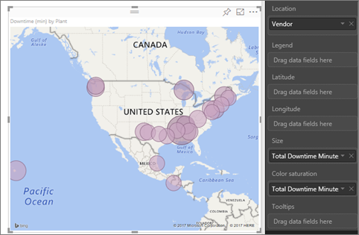

There are different types of Maps to visualize Data which are listed below,

**Basic Maps**

This map is a very basic version to populate data using blobs.

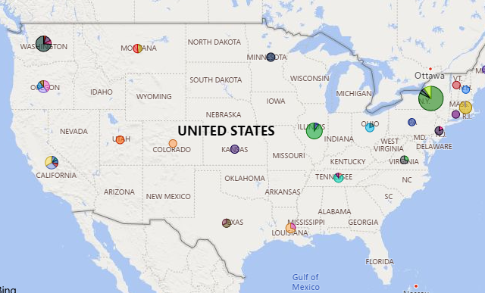

**Demo Exercise**

**Question:** From Office Supplies, Associate would like to know the total number of pencils supplied to the central region. Create a Basic Map to visualize the Data and enter the total number of pencils supplied to the central region in the answer box.

**Instruction:** Create a Basic Map and add Region to Location, item to Legend and Units to size. Filter Pencil in Items.

**Answer:** 498

**Solution:** From the below Visual, total number of pencils supplied for the central region is obtained.

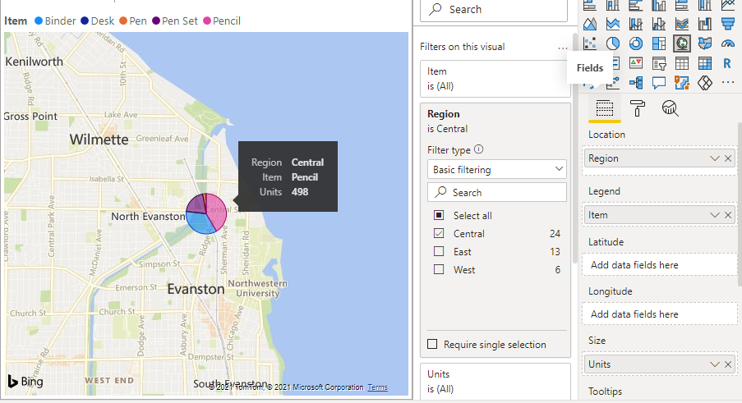

### Question 1

1/1 point (graded)

From Bank Customers Data, the Manager would like to know the total Balance of white collar customers in the England Region. Create a Basic Map to obtain the result and enter the total balance of white collar customers from England in the answer box.

correct

1345176.83

Loading

1. Hint (1 of 1): Create a Basic Map and add Region to Location, Job Classification to Legend and Balance to size and filter England in Filters.

Next Hint

Review

HintShow answer

Submit

Some problems have options such as save, reset, hints, or show answer. These options follow the Submit button.

### Question 2

1/1 point (graded)

A Bank contains data of customers with their balance details. Wales Branch Manager would like to know the total balance of female customers. Create a Basic Map to obtain the result and enter the total balance of Wales branch female customers in the answer box.

correct

315172.55

Loading

1. Hint (1 of 1): Create a Basic Map and add Region to Location, Gender to Legend and Balance to Size. Filter Wales in Region.

Next Hint

Review

HintShow answer

Submit

Some problems have options such as save, reset, hints, or show answer. These options follow the Submit button.

**Legend and Tooltips**

Legends and tooltips provide more information to viewers of your charts.

Legends divide a bar or line by category, while tooltips provide more information when you hover mouse over part of a chart.

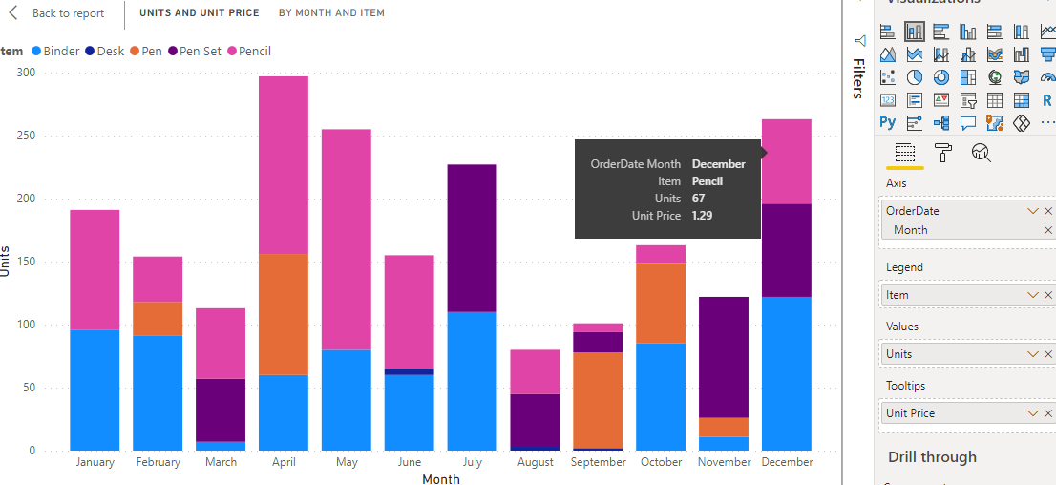

**Demo Exercise**

**Question 1:** From Office Supplies, create a bar graph and find Pencil Units value for the month of March. Find the answer and enter it in the answer box.

**Instruction:** Create a Bar chart and add Date (Month) to Axis, Units to Values, Items to Legend and Unit Price to tooltip. Hover Mouse over to March month and Pencil by seeing Legend Colour.

**Answer:** 56

**Solution:** From the below visual, we can see Pencil units on tooltip.

***Demo Exercise: Legends and Tooltips***

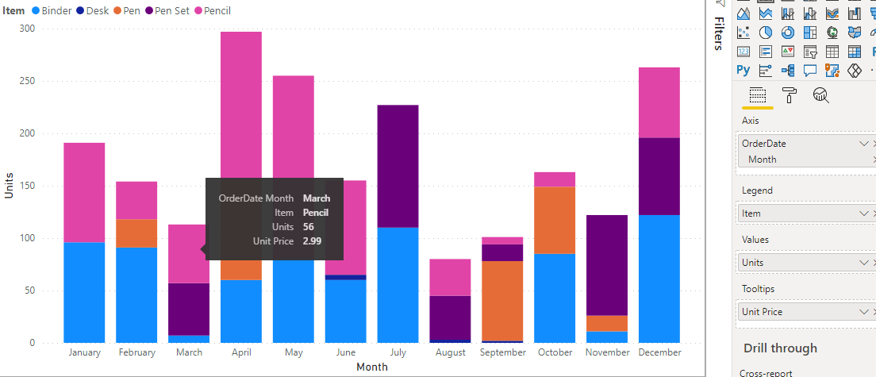

### Question 1

1/1 point (graded)

From Bank Customers Data, find Balance of white collar customers for the month of February using tooltip. Find the total balance of white collar customers for the month of February and enter it in the answer box.

correct

328119.67

Loading

1. Hint (1 of 1): Create a Bar chart and add Date (Month) to Axis, Job Classification to Legend, Balance to Values and hover mouse over February Month Balance by checking legend colour.

Next Hint

Review

HintShow answer

Submit

Some problems have options such as save, reset, hints, or show answer. These options follow the Submit button.

**Filters**

Filters in Power BI sort data and information based on some selected criteria. That is, you can select particular fields or values within fields and view only the information related to that.

There are 3 types of Filters in Power BI. They are mainly Page Level Filters, Report level Filters and Visual Level Filters. Each of them were explained below,

**Page-level filters**

Page level Filters only filter the data on a given page, which makes them useful for creating pages that focus on particular subsets of your data.

***Page Level Filters***

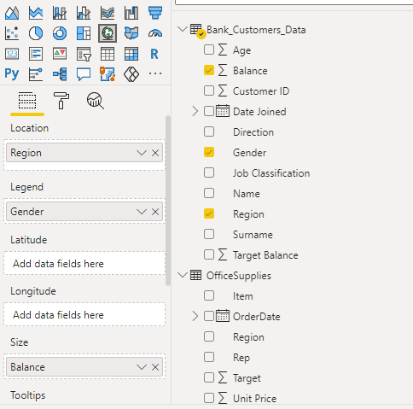

**Report-level filters**

Report level Filters are those that affect all of the data in the report, regardless of what you're looking at.

Click on the Filters section on Visual Pane.

***Filters***

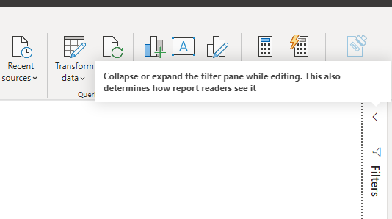

***Report Level Filter***

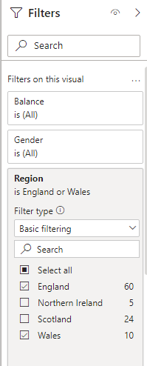

**Visual-level filters**

Visual Level Filters only filter the data on a given visual, whether that's a table, chart, card, slicer, etc. These are the most granular filters you can apply to your data, and they operate within the context of both the page-level and report-level filters.

Add Slicer Visual from Visualizations and add fields to the filter section which we need to filter.

***Visual Level Filters***

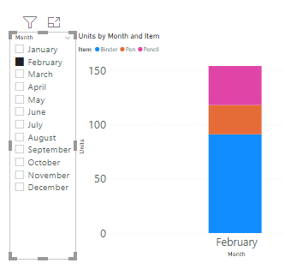

[Course](https://lms.codinginvaders.com/courses/course-v1:CodingInvaders+DATEST+1/course/) [Power BI Module 2](https://lms.codinginvaders.com/courses/course-v1:CodingInvaders+DATEST+1/course/#block-v1:CodingInvaders+DATEST+1+type@chapter+block@36557622a84d4f12b2bee8ab42b193b4) [Part 3 - Addition of New columns using Power Query](https://lms.codinginvaders.com/courses/course-v1:CodingInvaders+DATEST+1/course/#block-v1:CodingInvaders+DATEST+1+type@sequential+block@1c67ccd900434b35a326ac03c7620e92) What is Power Query in Power BI?

## **What is Power Query in Power BI?**

Bookmark this page

**What is Power Query in Power BI?**

Power Query in Power BI is useful to reshape and transform data according to our requirements. It is also useful to connect to different data sources and derive new columns in our sheet.

**Addition of Custom Columns using Power Query**

1. Launch Power BI Desktop and load some data.
2. From the Home tab on the ribbon, select Transform data, and then select Transform data from the menu.
3. From the Add Column tab on the ribbon, select Custom Column.
4. A list of available columns, in the Available columns list on the right will be displayed.
5. The initial name of your custom column, in the New column name box. You can rename this column.
6. Enter formula if required and click on OK.

***Custom Columns***

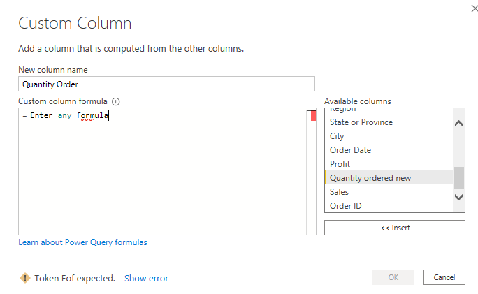

**Demo Exercise**

**Question:** From Office Supplies, Add a custom column to increase target by 2.00 and populate values in New column. Find the Target amount in the custom Column for date 09/01/2014 and enter it in the answer box?

**Instruction:** In the Query Editor, add a new custom column named New column and increase target column by 2.00.

**Answer:** 189

**Solution:** 2.00 is added to Target values and the same is populated in the new column.

***Demo Exercise: Custom Column***

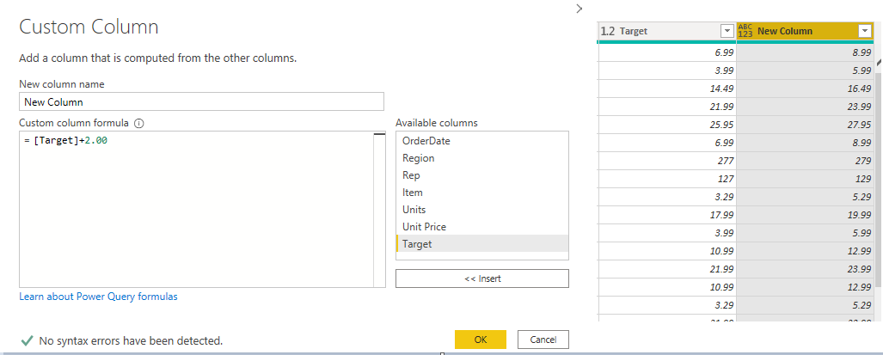

***Demo Exercise: Custom Column 2***

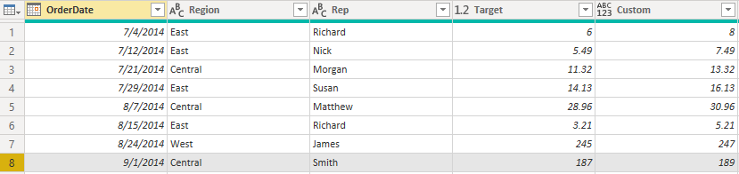

### Question 1

1/1 point (graded)

In Bank Customers Data, add 5000 bucks to each Customer's account and populate the new balance in the new column. Find the new balance amount for customer ID 100000011 and enter it in the answer box.

correct

44667.83

Loading

HintShow answer

Submit

Some problems have options such as save, reset, hints, or show

[Course](https://lms.codinginvaders.com/courses/course-v1:CodingInvaders+DATEST+1/course/) [Power BI Module 2](https://lms.codinginvaders.com/courses/course-v1:CodingInvaders+DATEST+1/course/#block-v1:CodingInvaders+DATEST+1+type@chapter+block@36557622a84d4f12b2bee8ab42b193b4) [Part 3 - Addition of New columns using Power Query](https://lms.codinginvaders.com/courses/course-v1:CodingInvaders+DATEST+1/course/#block-v1:CodingInvaders+DATEST+1+type@sequential+block@1c67ccd900434b35a326ac03c7620e92) Addition of Columns using Power Query

## **Addition of Columns using Power Query**

Bookmark this page

***Guided Exercise: Custom Column***

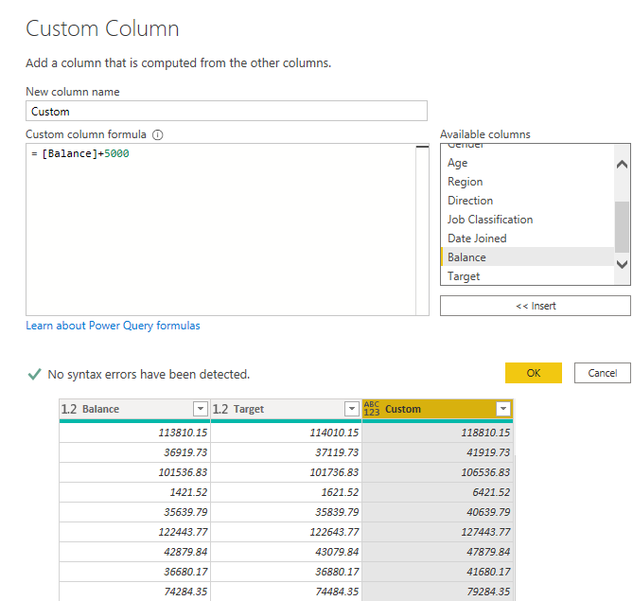

***Guided Exercise: Custom Column 2***

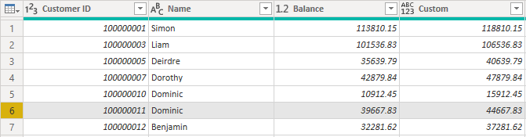

**Addition of Index Columns using Power Query**

* Launch Power BI Desktop and load some data.
* From the Home tab on the ribbon, select Transform data, and then select Transform data from the menu.
* From the Add Column tab on the ribbon, select **Index Column -**

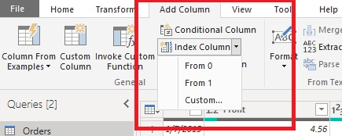

* Here we get 3 options (0 - column starts at 0, 1- column starts at 1, custom - column starts at given input number).
* If we select Custom, in the next dialog box, provide Index start number and increment for each row.

***Index Column***

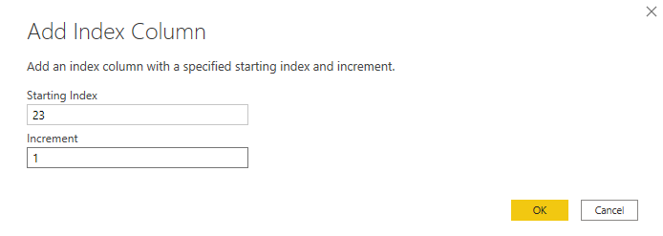

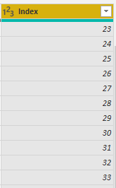

**Demo Exercise**

**Question:** Add an Index Column to Office supplies data starting index from 1. Find the Index number for Date 09/18/2014 and enter it in the Answer Box.

**Instruction:** Create an Index column in the Query Editor starting Index range from 1 in the Index column window.

**Answer:** 10

**Solution:** From below visual we can see Index number is 10 for above specified date.

***Demo Exercise: Index Column***

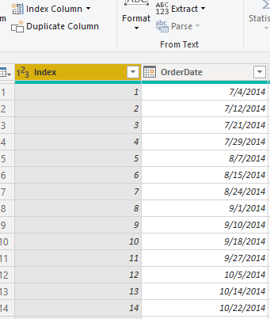

### Question 1

1/1 point (graded)

Add an Index Column to Bank Customers Data Index ranging number from 10 with increment +1. Find the Index number for the record whose “Customer ID” is 100000010 and enter it in the answer box.

correct

14

Loading

1. Hint (1 of 1): Create a Custom Index column with Index starting from 10 and increment +1.

Next Hint

Review

HintShow answer

Submit

Some problems have options such as save, reset, hints, or show answer. These options follow the Submit button.

Correct (1/1 point)

Review

**Addition of Conditional Columns using Power Query**

* Launch Power BI Desktop and load some data.
* From the Home tab on the ribbon, select Transform data, and then select Transform data from the menu.
* From the Add Column tab on the ribbon, select the conditional column.

***Conditional Column***

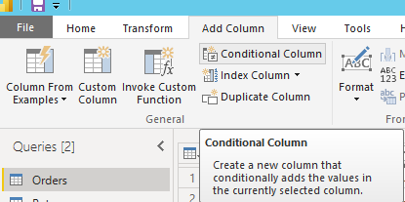

* In the new column name, enter a unique column name.

***Add Conditional Column***

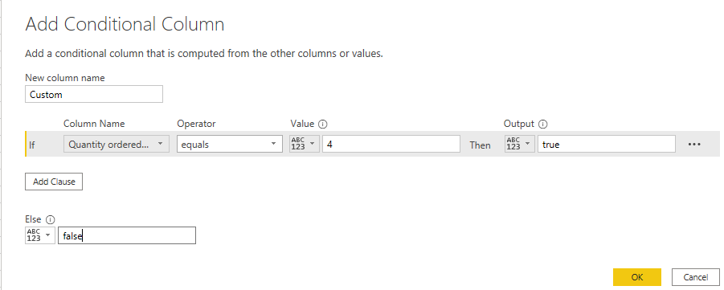

* Provide required conditions in fields specified along with desired output value as explained below.
* Result looks like below.

***Conditional Column***

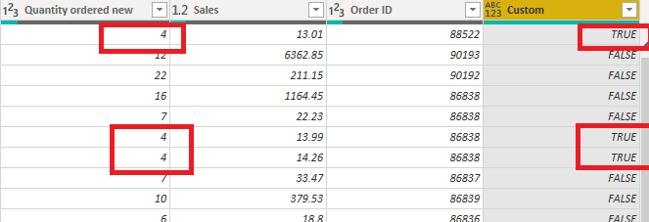

**Demo Exercise**

**Question:** Add a conditional column to Office Supplies Data with a condition if region= East (Condition is True) else false in a new column Condition. Find Condition for 7/21/2014 and enter it in the answer box.

**Instruction:** Create a conditional column and provide input as per above requirement.

**Answer:** False

**Solution:** From below visual, We can see False as a condition for the Date specified above.

***Demo Exercise: Conditional Column***

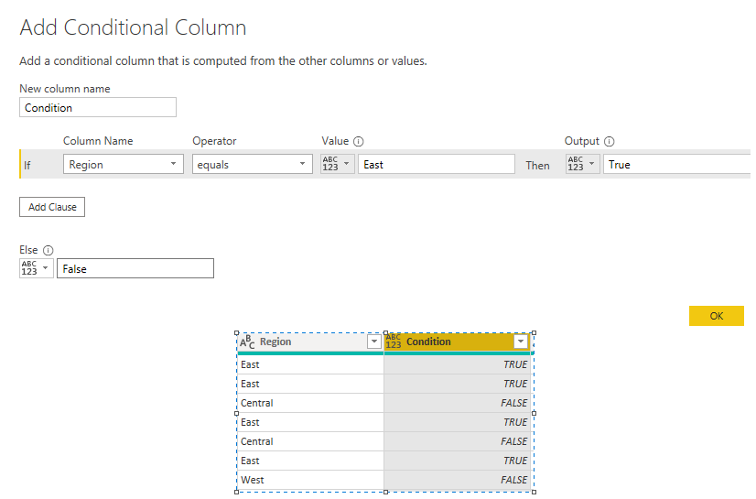

***Demo Exercise: Conditional Column 1***

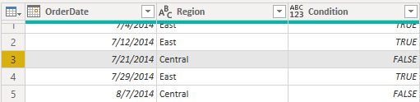

### Question 1

1/1 point (graded)

Add a conditional column to Bank Customers Data with a condition that if Balance is above 1,00,000, populate it as Regular customers else non Regular. Find the condition for customer ID 100000063 and enter it in the answer box.

correct

1. Hint (1 of 1): Create a conditional column and add a condition that if Balance is above 1,00,000 mark it as an important account.

Next Hint

Review

HintShow answer

Submit

[Course](https://lms.codinginvaders.com/courses/course-v1:CodingInvaders+DATEST+1/course/) [Power BI Module 2](https://lms.codinginvaders.com/courses/course-v1:CodingInvaders+DATEST+1/course/#block-v1:CodingInvaders+DATEST+1+type@chapter+block@36557622a84d4f12b2bee8ab42b193b4) [Part 3 - Addition of New columns using Power Query](https://lms.codinginvaders.com/courses/course-v1:CodingInvaders+DATEST+1/course/#block-v1:CodingInvaders+DATEST+1+type@sequential+block@1c67ccd900434b35a326ac03c7620e92) Formatting Text and Number Fields

## **Formatting Text and Number Fields**

Bookmark this page

**Formatting Text and Number Fields**

After performing Conditional Columns using Power Query, we can format text or number fields in below way,

* Load data in Power BI Power Query.
* Convert columns to the Decimal Number data type.
* Select the individual column and click on the left end of it and click on the Decimal Number.

***Data Type Change***

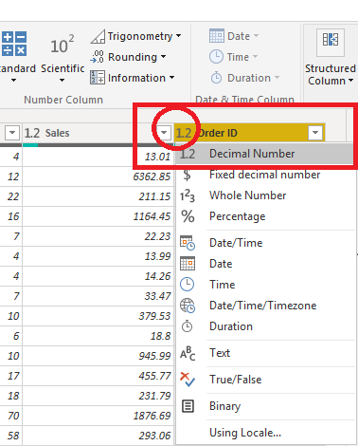

* Let’s apply Conditional formatting using Background Colors for the Sales column.
  + 1. Go to Report Mode and set visual as Table.
    2. Click on the down arrow for Sales Column and click on Conditional formatting.
    3. Click on Background Colours.

***Selecting Column for Formatting***

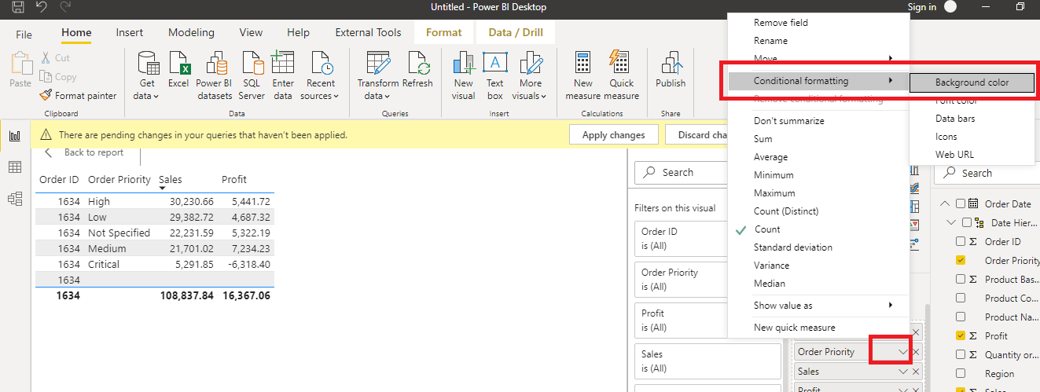

* Set the colours and preferences.

***Background Color***

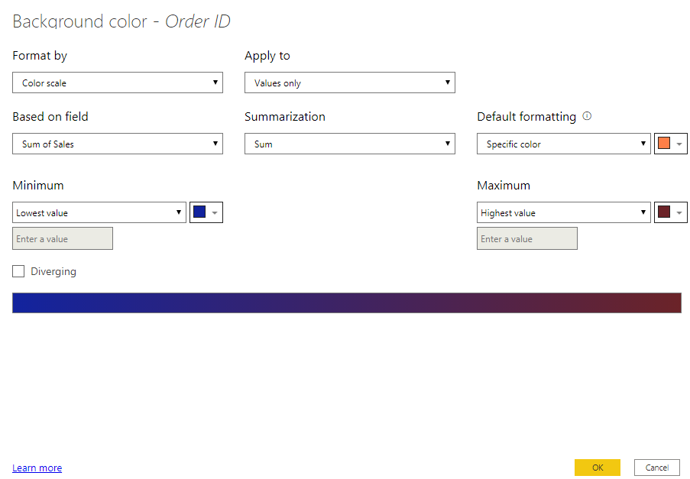

* Click on OK.
* The result will look like the following screen.

***Formatting : Background Colours***

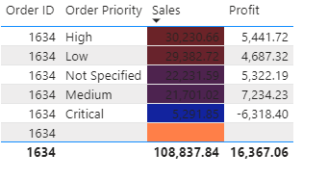

**Demo Exercise**

**Question:** Format cells and highlight them red which have a number of units less than 10. Use Region and representative wise Data for formatting.

**Instruction:** Highlight cells with red colour which have units less than 10.

**Answer: *Demo Exercise: Formatting Text and Number***

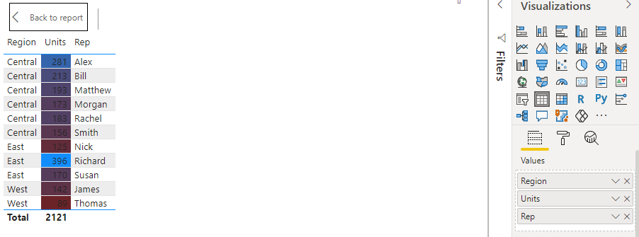

[Course](https://lms.codinginvaders.com/courses/course-v1:CodingInvaders+DATEST+1/course/) [Power BI Module 2](https://lms.codinginvaders.com/courses/course-v1:CodingInvaders+DATEST+1/course/#block-v1:CodingInvaders+DATEST+1+type@chapter+block@36557622a84d4f12b2bee8ab42b193b4) [Part 4 - Transforming Columns in Query Editor](https://lms.codinginvaders.com/courses/course-v1:CodingInvaders+DATEST+1/course/#block-v1:CodingInvaders+DATEST+1+type@sequential+block@5c68d33e5a284e39a675a532f2d49fcd) Header Row Transformation

## **Header Row Transformation**

Bookmark this page

**Header Row Transformation**

* In Power Query Editor, on the Home tab click Transform Group>Use first row as Headers / Use headers as first row.

***Header Row Transformation***

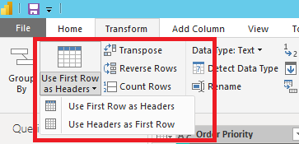

**Identifying and Changing Data Type of Attribute**

1. In the Power Query Editor, Click on Column that you need to change data type.
2. Then, in the ribbon in the Transform group click on column and click on the left end of column to change data type.

***Changing Data Type***



**Pivot / Unpivot Columns**

Pivot is used to interchange columns into rows or rows to columns for aggregating data. Using Power BI, it is very easy to Pivot and Unpivot Data. Below is the example on a demo dataset.

* Select the columns needed to pivot/unpivot.
* Click on Pivot or Unpivot columns in the Transform section on Ribbon.

***Pivot Columns***

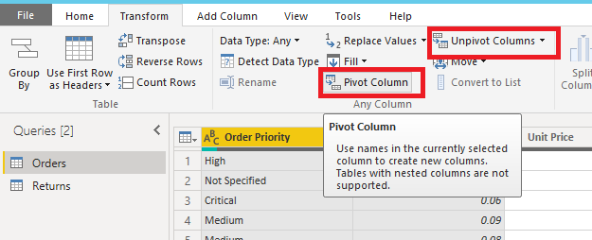

* Select columns which have values and click on Ok.

***Pivot Columns 1***

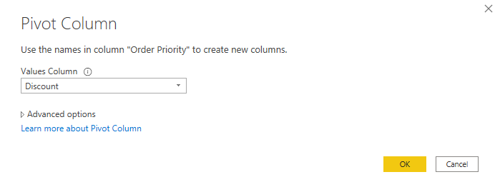

**Demo Exercise**

**Question:** Create pivot on Region to populate Units Data. Find the number of units in East for the date 7/12/2014 and enter it in the answer box.

**Instruction:** Select Region Column and click on Pivot.

**Answer:** 29

***Demo Exercise: Pivot***

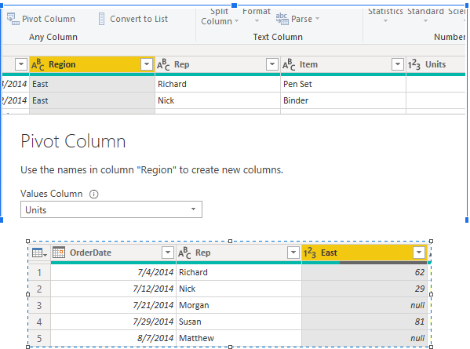

### Question 1

1/1 point (graded)

Create a Pivot on Job Classification column in Bank customer data to fetch Balance details. Find the Balance of White collar customer with Customer ID 100000012 and enter it in the answer box.

correct

32281.62

Loading

HintShow answer

Submit

Some problems have options such as save, reset, hints, or show answer. These options follow the Submit button.

**Join / Merge Columns**

Using Power BI, it is very easy to Split / Join /Merge Columns. Below are the steps to perform this,

* Select the columns in Power Query for Merging.
* In ribbon, click on **Add Columns > Merge Columns.**

***Add Column Ribbon***

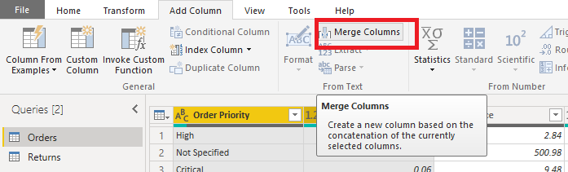

* After clicking on Merge Columns, a window will be opened.
* Add a separator (#, space, /…) in the window and give a new name to Merged Column.

***Merge Columns***

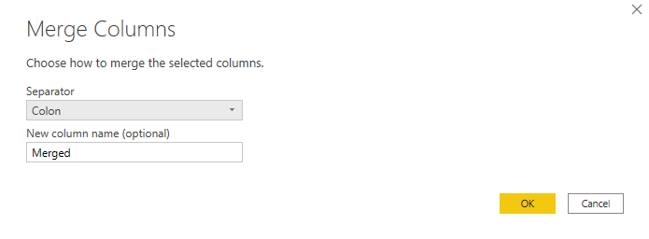

* After Merging Columns, close & Apply.

***Merged Column***

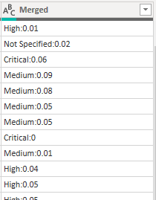

**Demo Exercise**

**Question:** Merge / Join Region and Rep Name in Office Supplies Data. Find String in Merged column for date 8/15/2014 and enter it in the answer box.

**Instruction:** Select two columns and click on Merge Columns. Then provide a separator in the next window if required.

**Answer:** EastRichard

***Demo Exercise: Join1***

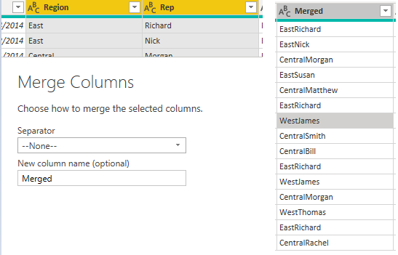

***Demo Exercise: Join2***

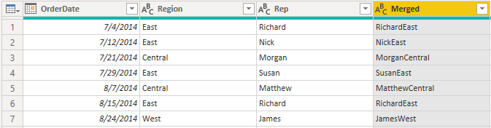

**Solution:** From the above visual, columns were merged without any separator.

### Question 1

1/1 point (graded)

In Bank Customers Data, split Balance column into two columns using (.) dot as separator. Find value in Balance 2 column for customer ID 100000007 and enter value in the answer box.

correct

84

Loading

HintShow answer

Submit

Some problems have options such as save, reset, hints, or show answer. These options follow the Submit button.

[Course](https://lms.codinginvaders.com/courses/course-v1:CodingInvaders+DATEST+1/course/) [Power BI Module 2](https://lms.codinginvaders.com/courses/course-v1:CodingInvaders+DATEST+1/course/#block-v1:CodingInvaders+DATEST+1+type@chapter+block@36557622a84d4f12b2bee8ab42b193b4) [Part 5 - Capstone Project Power BI 2](https://lms.codinginvaders.com/courses/course-v1:CodingInvaders+DATEST+1/course/#block-v1:CodingInvaders+DATEST+1+type@sequential+block@f42ff007eefb40eebc73d1f840713d72) Power BI 2 Capstone Project